ITF Wales Invite you to the…
ITF WALES
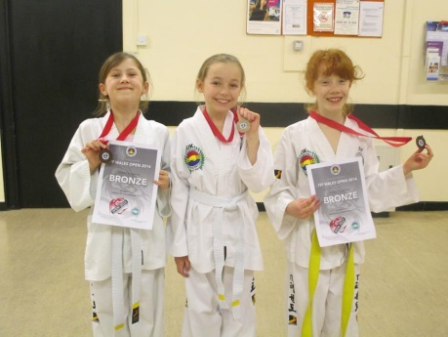
WHEN: Sunday 2nd February 9 am

WHERE: Cardiff University Talybont
Talybont Sports Centre
Cardiff
CF14 3UX
Free Parking available on site
Open to Colour belts – All ages
Junior Black belts (under 13)

CATEGORIES IN:
Sparring
Patterns
Special Technique (Juniors only)
Dragon’s Tail
High Kick

Entry Fee: £15 See entry form for full details
(£10 for 4-7 year olds)

Deadline for Entries : 22nd January

Entry Forms: Individual and school entry forms attached
ITF WALES OPEN 2020

Key Information
ITF WALES OPEN – February 2020
INDIVIDUAL ENTRY FORM
ITF WALES
Sunday 2nd February 2020 -9am  Cardiff University Talybont  Talybont Sports Centre  Cardiff, CF14 3UX |  |  | Please Return Completed Forms and Fee to your Taekwon-do Club/School
Competitor Details
Full Name: ______________________________________________________________________________________________________

Taekwon-do
School: ______________________________________________________________________________________________________

Date of Birth: _______/________/_______ Age: _________ Male Female

Grade: | White | Yellow | Green | Blue | Red | Black  (Juniors -13)

Events
Sparring  No  Yes  Under 13 13yrs Plus  Height CM: Weight Kg: |  | Patterns  No  Yes  Dragon’s Tail  4 – 7  Years  only  Yes  No |  | Special Technique  No  Yes  (Juniors -14yrs only)  High Kick  Yes  No
Entry and Declarations
Sparring and Patterns are open to 6 years plus. Special Technique is open to 7 – 13 years. 4 – 7 years compete in Dragons Tail and High Kick events.

Entry fee: £15 per competitor. £10 for 4 – 7 year olds. Spectators: Free.
All fees must be by cheque payable to ITF Wales and must be paid in full before the competition date.
There is a £5 late entry surcharge – payable for entries received after the 22nd January 2019.

I accept that my group may be merged with another or cancelled if insufficient competitors. I agree that the decision of officials is final. | I will wear ITF approved protective gear on head, hands, feet, gumshield, and groin guard (males). I will wear a white dobok without instructor stripes | This competition will be run in accordance with ITF rule set. I agree to the use of video and photography at this event.
I enclose full payment, I agree with the above and certify all details are correct:
Instructor declaration
Name ______________________________________

Signature: ______________________________________
Competitor declaration
Contact telephone _____________________________________
Signature
(Parent if under 16): __________________________________

ITF WALES OPEN – February 2020
SCHOOL ENTRY FORM
ITF WALES
Sunday 2nd February 2020 -9am  Cardiff University Talybont  Talybont Sports Centre  Cardiff, CF14 3UX |  | Please Return Completed Forms and Fee to your Taekwon-do Club/School
School Details
Taekwon-do
School: ______________________________________________________________________________________________________ Number of Competitors: __________________________

Instructor: ______________________________________________________________________________________________________
Entry and Declarations
Sparring and Patterns are open to 6 years plus. Special Technique is open to 7 – 13 years. 4 – 7 years compete in Dragons Tail and High Kick events.

Entry fee: £15 per competitor. £10 for 4 – 6 year olds. Spectators: Free.
All fees must be by cheque payable to ITF Wales and must be paid in full before the competition date. There is a £5 late entry surcharge – payable for entries received after the 22nd January 2019.

I accept that my group may be merged with another or cancelled if insufficient competitors. I agree that the decision of officials is final. | I will wear ITF approved protective gear on head, hands, feet, gumshield, and groin guard (males). I will wear a white dobok without instructor stripes | This competition will be run in accordance with ITF rule set. I agree to the use of video and photography at this event.
Instructor declaration
Name ______________________________________

Signature: ______________________________________
As the instructor of the competitors listed I agree with the above and have ensured all competitors (and parents if -16yrs) agree to the rule set and declarations. I certify and confirm all details are correct.
I enclose full payment for the competitors listed
Competitors

Full Name | DoB | Age | M/F | Grade  W/Y/G/B/R  (Black -13yrs only) | Sparring  Y/N | Height in CM  (-13s) or Weight in KG  (13yrs +) | Patterns  Y/N | Special Technique  Y/N | Dragon’s Tail  (4 – 6 yrs.)  Y/N | High Kick  (4 – 6 yrs.)  Y/N

Officials

Full Name | DoB | Age | M/F | Grade | Umpire qualifications  (If possible)

